 |  | Case Study Background
Instructions | This is the beginning of a case study that will span the rest of the course. You will be given more information with each part of the course. Every effort has been made to make the case study realistic in terms of helping you practice the tasks and duties of the Business Administrator. You will be asked to read the case study and then you will be given instructions about what to do with the information contained in the case study.
About the Case Study | The case study, which begins on the next page, is in narrative form. Read the case study and attempt to understand the information that is presented. Visually compare the information you find in the case study against the completed worksheets. You will then create the definitions specified in the worksheet using the Business Administrator application. Good luck and have fun. Your instructor will be available to answer questions.
If the Information Isn't There... | If certain information isn’t in the case study, leave it blank when creating your schema. For example, there is no address, phone, or fax information for the persons listed in this case study. We don’t want the case study to be inordinately long due to information that is incidental to the objectives of the case study. Don’t spend time trying to provide information that isn’t there.  Everything you need to create a successful, fully functioning Matrix database has been provided.
Case Study Process | Case Study Process:  - Discuss Matrix Schema as it relates to the definition being studied  - Discuss “How To” create specific definitions  - Present a portion of the case study related to those definitions  - Complete the Case Study Exercises using the completed worksheets  - Check your Answers

 |  | THE CASE STUDY: Honest Computer Company
About the company | The Honest Computer Company (HCC) is a custom-build personal computer company. They make personal computers for customers who order via the telephone. They will be expanding their order-receipt process to internet ordering in the near future.  They started their business with two people, Joe, and Dave. They have since grown to four people having added Darren and Angie.  Joe and Dave will continue to be the principals in the company responsible for actually building the computer systems. Darren and Angie will take orders, provide customer service, package and ship the computers, and send and receive invoices.  HCC makes no printers, modems, scanners, or any other computer-related products.
Enter Matrix... | The Honest Computer Company tracks their customers, computer components, and accounting through a paper-based system. Joe and Dave want to deal with the chaos of their expanding business. They want to track their computer products, and the computer’s component parts information. They also want to keep track of what’s sold to each customer.

 | Case Study Information: Types and Attributes
Types |  | The HCC assembles new microcomputers from components that are on the shelf. The components are from different manufacturers. Each component has cost, manufacturer’s source, and weight. In addition, each component has additional attributes according to the following:  - The Keyboard can be of different styles  - The Video Card can be either 2D or 3D with varying amounts of memory  - The Monitor has screen size (in inches) and dot-pitch.  - The Mouse can have 2 or 3 buttons  - The RAM Module has size  - The Hard Disk has capacity (in gigabytes).  - The Floppy Disk has a type.  - The CD-Rom has speed.  - The System Box has computer type, CPU Type, CPU Speed, and expansion slots.  NOTE: Please see type/attribute diagram on the page 2-15.  HCC makes desktop and tower personal computers from these components based on the Customer Order. They first assemble the System Box. The system box has, by default, a 1.44 MB, 3.5” Floppy disk. In addition, the system box is composed of the following:  - a specific CPU Type with a specific CPU speed  - a specific size and number of Hard Disk(s)  - a specific size and number of RAM module(s)  - a specific type of Video Card with a specific amount of SDRAM  - a CD-Rom (optional)  - a specified number of Expansion Slots.  After the system box is assembled, they add a specific Monitor with a specific screen size and dot-pitch, a specific Keyboard, and a specific Mouse. Documentation for all components is added to the computer. Sometimes Notes are added to a particular order.
Components |  | Each component type has a Cost, a manufacturer’s Source, and a specific Weight. The weight and cost both default to zero. The various manufacturers include: ACME, Diamond Multimedia, HCC, Intel, Micron, Microsoft, NEC, Toshiba, ViewSonic, and Western Digital.

Keyboard | The keyboard has a Keyboard Type attribute. HCC uses two keyboards, a standard-style 104 key keyboard, and a natural-style (split keypad) 104 key keyboard.
Monitor | The monitor type has Screen Size in Inches and Dot-Pitch attributes. HCC uses a variety of screen sizes, including: 15, 17, 19 and 21 inches. The default screen size is 15 inches. The dot-pitch ranges are .26 and .28, the default being .28. All monitors are SVGA with standard resolution values of 640x480 to 1920 x 1200.
Mouse | The mouse used on the computer is one of two kinds, 2 button or 3 button. The default is 2 button.
RAM Module | The RAM module(s) is (are) installed in each computer. The RAM module is sized in the following capacities: 32, 64 and 128MB. The default RAM size is one (1) 32MB module. Each computer may have up to four RAM modules, totaling up to 512MB of RAM.
Floppy Disk | The floppy disk can be of the type Standard (1.44MB) or Super (120MB). The default is Standard.
Video Card | The video card can be either 2D or 3D, with varying amounts of SDRAM ranging from 4 MB to 32 MB. The default for both cards is 4 MB.
System Box | The system box type has Computer Type, CPU type, CPU speed and Expansion slots as attributes. The computer type can be Desktop or Tower. The default type is Desktop. The CPU installed in the computer can be a Celeron, Pentium II or Pentium III. The default CPU type is unknown. The CPU speed can be 400, 500, 600, 700, 800, or 900MHz. The default CPU speed is unknown. There can be between 3 to 8 expansion slots (inclusive) on the system. The default number of expansion slots is 5.
Hard Disk | The hard disk can have a capacity in gigabytes of 5, 10, 15 or 20. The default is 5.
CD-Rom | The CD-Rom may have a different speed according to the following values: 24X, 32X and 40X. The default is 24X.

 | Schema Diagram: Types and Attributes
Components Diagram |  | You may find the following type/attribute drawing helpful in setting up your schema to solve the case study problem.  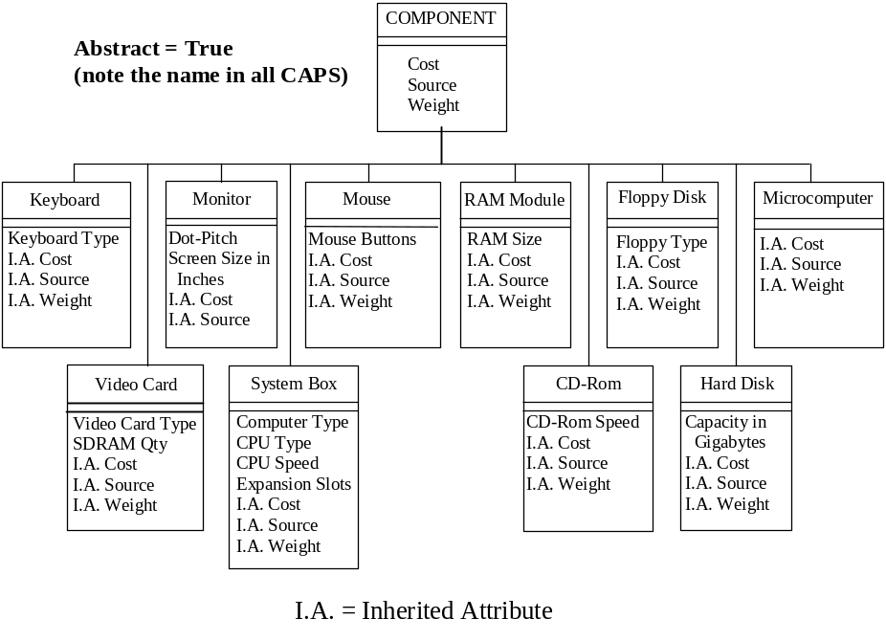
NOTE: |  | When selecting a parent or derivable type, select the immediate parent. The immediate type will automatically “pick-up” the parent structure immediately above it.  For example: The immediate parent for Customer Order is DOCUMENT. While creating the Customer Order type, when you select DOCUMENT as the parent for Customer Order, it will automatically pick up or inherit the attributes from DOCUMENT.

 |  | Schema Diagram: Types and Attributes – Continued
Documents Diagram | All documents are derived from the Type DOCUMENT.  In order to create and attach an Attachment/Note to an object, you must first activate the “Attachment” type by creating it.  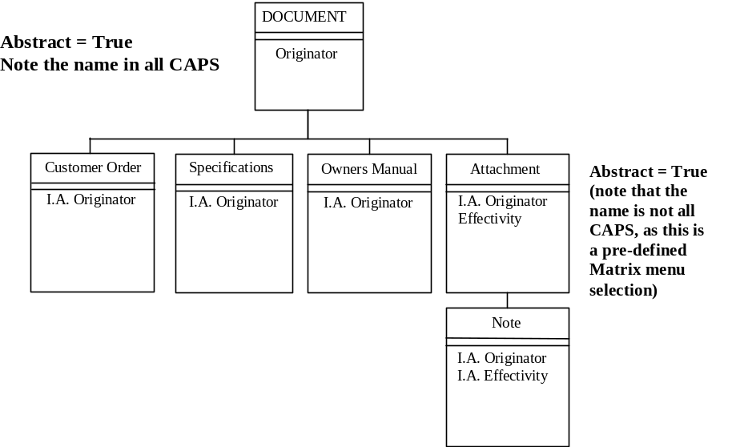

 | Case Study Exercise: Types and Attributes
Instructions |  | - On the next page are Attribute and Type definition worksheets.  - Refer to the Case Study to read/check the content of the two worksheets.  - After you have read/checked the contents of the worksheets, start the “Business” application.  - Set your context to “creator” to create the definitions. (under the “Session” menu item)  - Use the “Business” application to create attributes 1-8 first. Then use the “MQL” application to run the script that will create attributes 9-21. NOTE: Use both the toolbar and the menu items to create the attributes.  - Use the “Business” application to create the parent types first, then the child types. NOTE: Use both the toolbar and the menu items to create the types.  If you make a mistake after you’ve created an attribute or a type, select the item, select “OPEN” from the file menu, then select “EDIT”. You will see a dialog screen. Revise the information as needed, then select the “EDIT” button to confirm. You can also “double click” on the icon to be edited.
Time |  | You will have 75 minutes to complete this exercise.

 |  |  |  |  | Attribute Definitions Worksheet
Instructions |  |  |  | Use this worksheet to specify your attribute definitions. Use the default icon. Keep descriptions short, but meaningful.
No | Attribute Name |  | Attribute Description |  |  |  | Type  (String, Integer, Real, Boolean) |  |  | Default Value | Operator | Range of Values
 | Computer Type |  | The system box case design. |  |  |  | string |  |  | Desktop | = | Desktop, Tower
 | Screen Size |  | The size of the monitor screen. |  |  |  | real |  |  | 15
 | Dot-Pitch |  | The dot-pitch of the monitor. |  |  |  | real |  |  | .28 | = | .26, .28
 | Keyboard Type |  | The type of keyboard. |  |  |  | string |  |  | Standard | = | Standard, Natural
 | Mouse Buttons |  | The number of buttons on the mouse. |  |  |  | integer |  |  | 2 | = | 2, 3
 | Capacity in  Gigabytes |  | The capacity of the hard disk. |  |  |  | integer |  |  | 5 | = | 5, 10, 15, 20
 | Floppy Type |  | The type of floppy disk. |  |  |  | string |  |  | Standard | = | Standard, Super
 | CD-Rom Speed |  | The speed of the CD-Rom. |  |  |  | string |  |  | 24X | = | 24X, 32X, 40X
 | Video card |  | It can be 2D or 3D |  |  |  |  |  |  | 4 MB | between | 4MB to 32 MB
 | RAM module |  | Installed in each computer. And each computer may have 4 RAM module. |  |  |  |  |  |  | 32 MB | = | 32 MB , 64 MB, 128 MB
 | Hard disk |  | Hard disk Capacity in Gigabyte. |  |  |  |  |  |  | 5 | = | 5,10,15
 | Computer type |  | Desktop or tower |  |  |  |  |  |  | desktop
 | CPU type |  | The CPU installed in the computer can be a Celeron, Pentium II or Pentium III. The default CPU type is unknown |  |  |  |  |  |  | unknown
 | CPU Speed |  | The CPU speed can be 400, 500, 600, 700, 800, or 900MHz . |  |  |  |  |  |  | unknown |  | 400, 500, 600, 700, 800, or 900MHz
 | mouse |  | It may be 2 button or 3 button |  |  |  |  |  |  | 2
 | Cost |  | Cost of the computer. |  |  |  | integer |  |  |  | =,between
 | Quantity |  |  |  |  |  | integer |  |  |  | =
 | weight |  | Weight of computers |  |  |  | real |  |  |  | Between, =
 | effectivity |  |  |  |  |  | string
 | Expansion Slot |  | Expansion Slot |  |  |  | string |  |  | between |  | 3 to 8
 | source |  | source |  |  |  | string
 | Order Qty |  | Order Qty |  |  |  | string
 | SDRAM Quantity |  | SDRAM Quantity |  |  |  | string |  |  | 4 MB |  | 4 MB to 32 MB
 | Floppy disk |  | Standard and super |  |  |  |  |  |  | 1.44 MB |  | 1.44 MB to 120 MB
 |  |  |  |  | Type Definition Worksheet
Instructions |  |  |  | Use this worksheet to specify the type definitions. Use the default icon.
No |  | Type Name | Description |  |  | Abstract  Yes/No |  | Derived From (Parent) | Explicit Attributes |  | Triggers |  | Methods

 |  |  |  | Attribute Definitions Worksheet: Answers
Instructions |  |  | Use this worksheet to specify your attribute definitions. Use the default icon. Keep descriptions short, but meaningful. NOTE: The values listed below are separated by a comma. Do NOT list all values as a single value. Each value must be separately defined.
No |  | Attribute Name |  | Attribute Description | Type | Default Value | Operator | Range of Values
 |  | Computer Type |  | The system box case design. | string | Desktop | = | Desktop, Tower
 |  | Screen Size |  | The size of the monitor screen. | real | 15
 |  | Dot-Pitch |  | The dot-pitch of the monitor. | real | .28 | = | .26, .28
 |  | Keyboard Type |  | The type of keyboard. | string | Standard | = | Standard, Natural
 |  | Mouse Buttons |  | The number of buttons on the mouse. | integer | 2 | = | 2, 3
 |  | Capacity in  Gigabytes |  | The capacity of the hard disk. | integer | 5 | = | 5, 10, 15, 20
 |  | Floppy Type |  | The type of floppy disk. | string | Standard | = | Standard, Super
 |  | CD-Rom Speed |  | The speed of the CD-Rom. | string | 24X | = | 24X, 32X, 40X

Similarly create attributes listed below ( keep name and description same and type as string)

- Video Card Type 12. CPU Speed 15. Cost 18. Quantity 21. Effectivity
- SDRAM Quantity 13. Expansion Slots 16. Source 19. OrderQty
11. CPU Type 14. RAM Size 17. Weight 20. Originator

Define Unit of Measure (UOM) for Attribute - Screen Size
Default: inches
Available UOM: mm, cm
Write appropriate conversion formula for inches to mm; and inches to cm.

 | Type Definition Worksheet: Answers
Instructions |  | Use this worksheet to specify the type definitions.  NOTE: You do not need to select new icons for types number 1, 12 and 16, as these are abstract types and can never be instantiated.

No | Type Name | Description | Abstract  Yes/No | Derived From (Parent) | Explicit Attributes | Suggested Icon
 | COMPONENT | Component part. | Yes |  | Cost, Source, Weight | N/A
 | Keyboard | Computer keyboard. | No | COMPONENT | Keyboard type | Keyboard.gif
 | Monitor | Computer monitor. | No | COMPONENT | Dot-Pitch,  Screen Size in Inches | Monitor.gif
 | Mouse | Computer mouse. | No | COMPONENT | Mouse Buttons | Mouse.gif
 | RAM Module | Computer RAM. | No | COMPONENT | RAM Size | RAM.gif
 | Floppy Disk | Computer floppy disk. | No | COMPONENT | Floppy type | Floppy.gif
 | Microcomputer | A type of computer. | No | COMPONENT |  | Microcomputer.gif
 | Video Card | Computer video card. | No | COMPONENT | Video Card Type,  SDRAM Quantity | Vidcard.gif
 | System Box | Computer system box. | No | COMPONENT | Computer Type,  CPU Speed, CPU Type, Expansion Slots | Sysbox.gif
 | CD-Rom | Computer CD-Rom. | No | COMPONENT | CD-Rom Speed | Cdrom.gif
 | Hard Disk | Computer hard disk. | No | COMPONENT | Capacity in Gigabytes | HardDisk.gif
 | DOCUMENT | Documentation for the computer. | Yes |  | Originator | N/A
 | Customer Order | Customer order information. | No | DOCUMENT |  | CustOrd.gif
 | Specification | Spec sheet for a component. | No | DOCUMENT |  | Specific.gif
 | Owner Manual | Owner guide for a microcomputer. | No | DOCUMENT |  | OwnerMan.gif
 | Attachment | Attachment Object. | Yes | DOCUMENT | Effectivity | N/A
 | Note | Note for the Customer Order. | No | Attachment |  | Note.gif

NOTE: The Attachment type (# 16) has been left as lower case by design. In order for the system to use the type Attachment, it must be created as a type that matches, in both spelling and case, the Matrix User menu selection of - Object, New, Attachment.

 | Case Study: Relationships
Overview | This portion of the case study provides information that should help you determine the relationships between the various types.
Relationships | Microcomputer Assembly Relationship: For each order there will be a computer built. The Microcomputer is related to the Monitor, Mouse, Keyboard and System Box. For each computer there will be one and only one Keyboard, Monitor, Mouse, and System box. The individual components relate to many different computers.  System Box Assembly Relationship: For each Microcomputer there will be a System Box built. The System Box is related to the Components that are inside it. There might be multiple Hard Disks installed on the computer therefore, a quantity of components should be included on the relationship. The individual components relate to many different computers.  Order-Micro Relationship: The Customer Order is related to the Microcomputer and it’s associated components. There may be more than one Microcomputer ordered, so there should be a quantity on the relationship.  Order-Note Relationship: The Customer Order may need changes or modifications AFTER the order has been received. This relationship allows a Note to be attached to the Customer Order.  Documentation Relationship: Each Component of the Microcomputer may have a Specification sheet connected to it, and the Microcomputer itself may have an Owner Manual connected to it.

 |  | Case Study: Relationship Diagrams
Relationships | There are five relationships:  - The relationship between: the Microcomputer and its Components  - The relationship between: the System Box and its Components.  - The relationship between: the Customer Order and the Microcomputer.  - The relationship between: the Notes and the Customer Order.  - The relationship between: the Specification sheet and the Components  the Owner Manual and the Components
Relationship 1: Microcomputer Assembly | 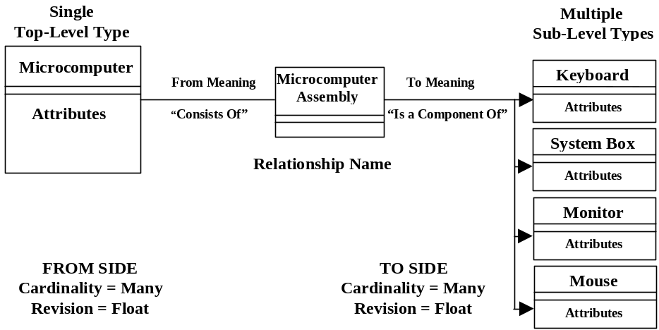
Relationship 2:  System Box Assembly | 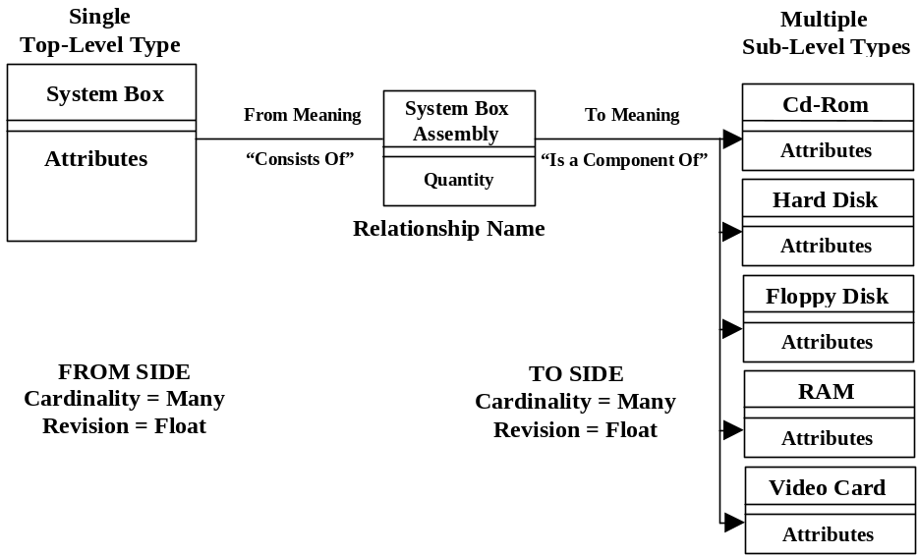

Relationship 3:  Order-Micro | 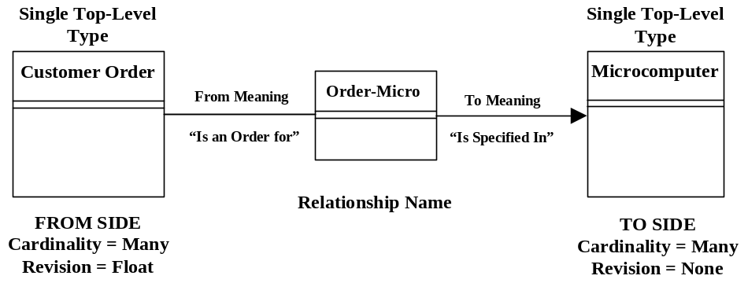
Relationship 4:  Order-Note | 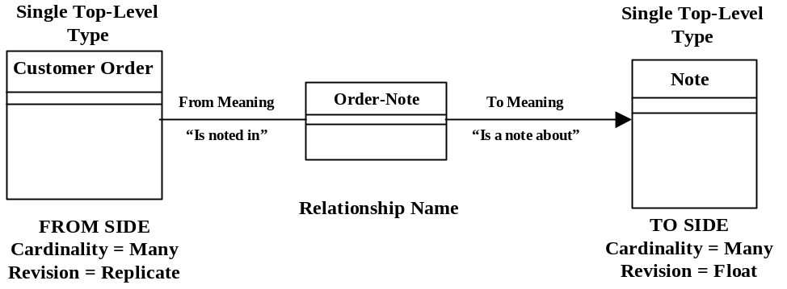
Relationship 5:  Documentation | 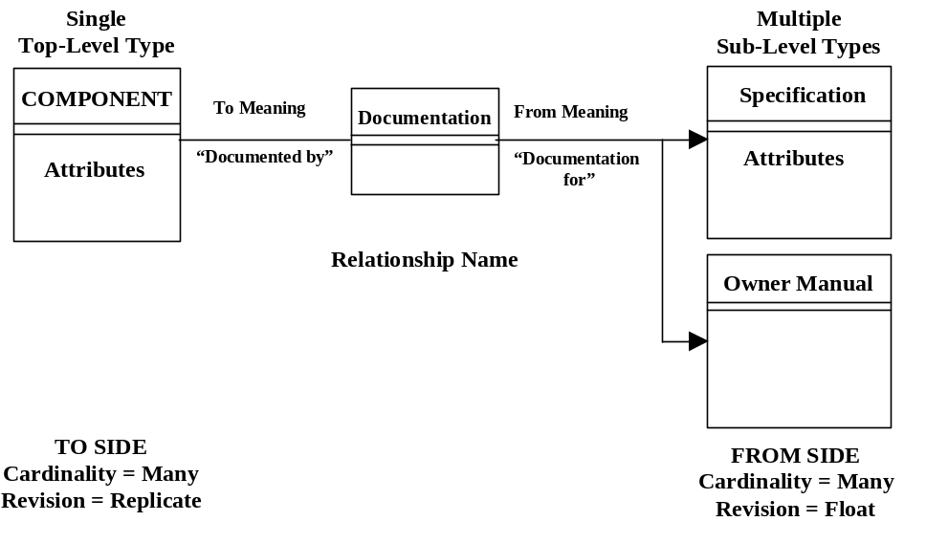
Case Study Exercise | Instructions:  - Read information in the Case Study on relationships.  - Complete the Relationship Worksheets - Next Page  - Create the Relationships with the “Business” application.
Time | You will have 30 Minutes to complete the lab.

 |  |  | Relationship Definition Worksheet
Instructions |  | Use this worksheet to specify the relationship definitions, that is, the relationships between the different defined types. Use the default icon.
Information
Relationship Name

Description

Attributes

Triggers

From Meaning

From Types

From Cardinality
(One or Many)

From Revision Behavior
(None, Float, Replicate)

From Clone Behavior
(None, Float, Replicate)

To Meaning

To Types

To Cardinality
(One or Many)

To Revision Behavior
(None, Float, Replicate)

To Clone Behavior
(None, Float, Replicate)

 | Relationship Definition Worksheet: Answers
Instructions | Use this worksheet to specify the relationship definitions, that is, the relationships between the different defined types. Use the default icon.

Information
Relationship Name | Microcomputer Assembly | System Box Assembly | Order-Micro | Order-Note | Documentation
Description | Relationship for assembling the major components of the Microcomputer. | Relationship for assembling the major components of the System Box. | Relationship between the Customer Order and the Microcomputer. | Relationship for attaching Note(s) to the Customer Order | Documentation that accompanies the Microcomputer
Attributes | Quantity | Quantity
Triggers
From Meaning | Consists of | Consists of | Is an Order for | Is noted in | Documented In
From Types | Microcomputer | System Box | Customer Order | Customer Order | COMPONENT
From Cardinality  (1-1, 1-n, n-n) | Many | Many | Many | Many | Many
From Revision Behavior  (None, Float, Replicate) | Float | Float | Float | Float | Replicate
From Clone Behavior  (None, Float, Replicate) | None | None | None | None | None
To Meaning | Is a component of | Is a component of | Is specified in | Is a Note about | Documentation for
To Types | Keyboard, Monitor, Mouse, System Box | CD-Rom,  Floppy Disk,  Hard Disk,  RAM Module, Video Card | Microcomputer | Note | Specification  Owner Manual
To Cardinality  (1-1, 1-n, n-n) | Many | Many | Many | Many | Many
To Revision Behavior  (None, Float, Replicate) | Float | Float | None | Replicate | Float
To Clone Behavior  (None, Float, Replicate) | None | None | None | None | None

All of the above relationships, with the exception of the Documentation relationship, are designed for use from an “Engineering” point of view. If you would like your arrows reversed, switch the “From” and “To” fields.

 |  | Case Study: Programs and Formats
Overview | This portion of the case study provides information that should help you determine and understand what the Programs and Formats will be used for.
Programs and Formats | Joe and Dave want to be able to check in paperwork related to the microcomputer business object. This information is typically in a letter or spreadsheet format. These files will be:  - Files in a .DOC format. This is MS-Word. This application is to be used for viewing and editing.  - Files in a .XLS format. This is MS-Excel. This application is to be used for viewing and editing

 |  | Case Study: Format Diagram
Format Diagram | 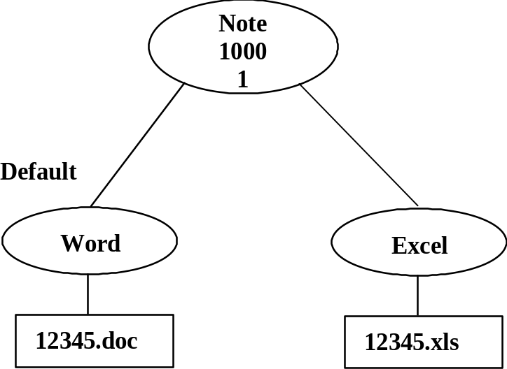
Case Study Instructions | - Re-read case study related to programs and formats (page 2-68)  - Complete Program Item and Format Worksheet - Next Pages  - Use the “Business” application to create programs and formats
TIME | You will have 10 Minutes to complete this case study exercise.

 | Program Item Definition Worksheet
Instructions | Use this worksheet to specify the Program definitions. Use the default icon.
Information | - Program Item | - Program Item | - Program Item
Program Item Name
Icon Location
Program Item Description
Program Type
Execute – Immediate/Deferred
Needs Business Object
Downloadable
Hidden
Code

 | Format Definition Worksheet
Instructions | Use this worksheet to specify the format definitions. Use the default icon.
Information | - Format | - Format | - Format
Format Name
Software Version
Format Description
File Suffix
Edit Command Program Item
View Command Program Item
Print Command Program Item

 | Program Item Definition Worksheet: Answers
Instructions | Use this worksheet to specify the format definitions. Use the default icon.
Information | - Program Item | - Program Item | - Program Item  (if applicable)
Program Name | Word | Excel | Spicer
Program Description | MS -Word | MS-Excel | Viewing application
Program Type | External | External | External
Execute | Immediate | Immediate | Immediate
Needs Business Object | Yes | Yes | Yes
Code | c:\program files\microsoft  office\office\winword.exe  “${FILENAME}” | c:\program files\microsoft  office\office\excel.exe  “${FILENAME}” | c:\spicer\image\image.exe  “${FILENAME}”

NOTE: The Program Path and Executables for Program Items 1 + 2 are from MS Office 97 in a default installation.
The Program Path and Executable for Program Item 3 is from Spicer’s Imagenation 5.11 (if installed)

 | Format Definition Worksheet: Answers
Instructions | Use this worksheet to specify the format definitions. Use the default icon.
Information | - Format | - Format | - Format
Format Name | Word | Excel
Software Version
Suffix | .doc | .xls
Format Description | Word Documents | Excel Spreadsheets
View Program Item | Word (Spicer, if installed) | Excel (Spicer, if installed)
Edit Program Item | Word | Excel
Print Program Item

 |  | Case Study: Store Definition
Case Study Information: Stores | HCC wants to store all information in a storage location called “Production”. They want Matrix to have the most amount of control over the files that are stored. They will use the default location for the stores.
Case Study Instructions | - Complete the Worksheet on the next page  - Use the “System” application to create the stores.
TIME | You will have 5 Minutes to complete this case study exercise.

 | Store Definitions Worksheet
Instructions | Use this worksheet to specify the store definitions. Use the default icon.
Information |  | - Store | - Store | - Store
Store Name
Store Icon
Store Description
Store Type
Path
Host Name
FTP User Name
FTP Password
Data Table space
Index Table space

 |  | Store Definitions Worksheet: Answers
Instructions | Use this worksheet to specify the store definitions. Use the default icon.
Information |  | - Store | - Store | - Store
Store Name |  | Production
Store Description |  | Storage for production data.
Store Type |  | Captured
Path |  | D:\Temp
Host Name
FTP Username
FTP Password
Data Tablespace
Index Tablespace

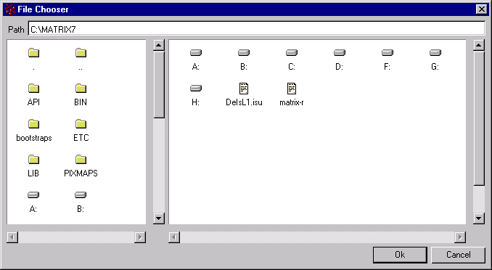

 |  | Case Study Exercise
Case Study Information | HCC has determined that to organize their business objects they must use Matrix to create the following vaults:  - Manufacturing in the default table space  - Engineering in the default table space.  HCC has decided that it will use the default table space since they are still a small operation. In the future, they might need to move the vaults.
Instructions | - Complete the worksheet - Next Page  - Use the “System” application to create the Vault definitions.
TIME | You will have 5 minutes to complete this Case Study Exercise.

 |  | Vault Definitions Worksheet
Instructions | Use this worksheet to specify the Vault definitions.
Information |  | Vault 1 | Vault 2 | Vault 3 | Vault4
Name
Icon
Description
Index Tablespace
Data Table space
Type
Server
Interface
Map

 | Vault Definitions Worksheet: Answers
Instructions | Use this worksheet to specify the Vault definitions. Use the default Vault icon.
Information | Vault 1 | Vault 2 | Vault 3 | Vault 4
Name | Manufacturing | Engineering
Description | Manufacturing vault. | Engineering vault.
Vault Type | Local | Local

 |  | Case Study Exercise
Case Study Information | There are four people in the company. Joe, Dave, Darren, and Angie. The HCC corporation has two major groups: Sales and Manufacturing. The Sales group takes orders over the phone, and the Manufacturing group builds the computers. Joe, Dave, Darren and Angie are in the Manufacturing group, and Joe is in the Sales group.  Joe is assigned the role of president, Dave is assigned the role of vice president, and both use the Engineering vault. Darren and Angie both are assigned to the roles of shipper and packer, and both use the Manufacturing vault. Joe and Dave have full access to all information in the system and can set up the system with the “Business” interface, but only Joe has System Administration permission.  Darren and Angie are full users of the system, but are not allowed into the Business or System Administration function. They will have access to everything.  No passwords are assigned to anyone at this time.
Case Study Diagram of the Groups, Roles, and Person Relationship | 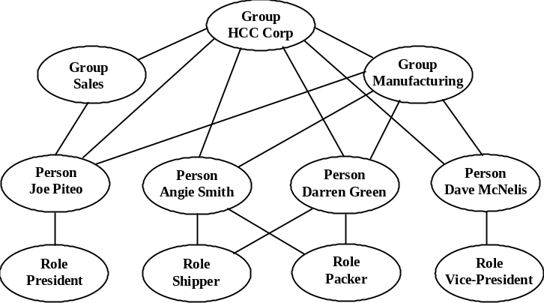
Instructions | - Read the case study  - Complete the worksheets for the Group, Role, and Person - Next Page  - Use the “Business” application to create the groups, roles, and persons. HINT: You may want to create Groups first, then Roles, then Persons. Your instructor will be available to answer questions.  - Check your work with the answer worksheets provided.
TIME | You will have 30 Minutes to complete the Case Study Exercises.

 |  | Group Definition Worksheet
Instructions | Use this worksheet to specify the group definitions. Use the default icon. Keep descriptions short.

Group Name
Description
Parent Group
Child Group(s)
Assigned Person(s)

 |  | Role Definition Worksheet
Instructions | Use this worksheet to specify the role definitions. Use the default icon.

Role Name
Role Description
Parent Role
Child Role(s)
Assigned Person(s)

`
 |  | Person Definition Worksheet
Instructions | Use this worksheet to specify the person definitions. Use the default icon.

Information | - Person | - Person | - Person | - Person
Person Name
Icon
Full Name
Comment
Address
Phone
Fax
Email
Vault
Site
User Access
Admin Access
Password
Type
Group Assignment
Role Assignment

 |  | Group Definition Worksheet: Answers
Instructions | Use this worksheet to specify the group definitions. Use the default icon. Keep descriptions short.  NOTE: While you can make Person and Role assignments here, you might find it easier to make the assignments in the “Person” definitions. This will become very clear when you begin to set up databases with Matrix Query Language (MQL). See Person Definition Worksheet for assignments.

Information | - Group | - Group | - Group | - Group | - Group
Group Name | HCC | Sales | Manufacturing
Description | Employees of Honest Computer Company | Employees in the Sales group. | Employees in the Manufacturing Group
Parent Group |  | HCC | HCC
Child Group | Sales, Manufacturing
Assigned Person(s) | Joe, Dave, Angie, Darren | Joe | Joe, Dave, Angie, Darren

 |  | Role Definition Worksheet: Answers
Instructions | Use this worksheet to specify the role definitions. Use the default icon.  NOTE: While you can make Person and Group assignments here, you might find it easier to make the assignments in the “Person” definitions. This will become very clear when you begin to set up databases with Matrix Query Language (MQL). See Person Definition Worksheet for assignments.

Role Name | President | Vice President | Packer | Shipper
Role Description | President of HCC | Vice President of HCC | Person who packs the Microcomputer | Person who ships the Microcomputer
Parent Role
Child Roles
Assigned Person(s) | Joe | Dave | Angie, Darren | Angie, Darren

 |  | Person Definition Worksheet: Answers
Instructions | Use this worksheet to specify the person definitions. Use the default icon.

Information | - Person | - Person | - Person | - Person
Person Name | Joe | Dave | Darren | Angie
Full Name | Joe Jackson | Dave Matthews | Darren Green | Angie Smith
Comment | President | Vice-President
Address
Phone
Fax
IconMail | Yes | Yes | Yes | Yes
Email
Vault | Engineering | Engineering | Manufacturing | Manufacturing
Site
User Access | All | All | All | All
Admin Access | All | All
Password | No Password | No Password | No Password | No Password
Type | Application, Full, Business, System | Application, Full, Business | Application, Full | Application, Full
Group Assignment | HCC, Sales, Manufacturing | HCC, Manufacturing | HCC, Manufacturing | HCC, Manufacturing
Role Assignment | President | Vice-President | Shipper, Packer | Shipper, Packer

 |  | Case Study Exercise: Policy Definition
Case Study Information: States in the Life Cycle | This is the way the HCC business process works:  - First, the order is received. A customer calls HCC to order a computer. The phone is answered by either Darren or Angie. They receive the customer’s order by capturing the information. They verify type of system box, monitor size and resolution, type of keyboard, type of mouse, hard disc size, floppy disk type, CD-Rom, CPU type and speed, video card type and SDRAM, number of expansion slots, and amount of RAM. Next, they verify that the information obtained is correct.  - At the conclusion of the telephone conversation they have an order that is ready to be filled. They check the inventory (NOTE: it will always be available) to see if they have all the parts. They approve the order and give the order to either Joe or Dave. Joe or Dave then check the customer’s records and either approve or reject the customer order. Once the order is approved they take the parts off the shelf and build the computer.  - When the computer is finished it is ready to be shipped. Darren or Angie are notified. They pick up the completed computer, and package it with the Specifications sheets and Owner Manual. Just before they send the computer they get a final sign off from Joe that indicates the order can be shipped.  - The Order is Shipped.
Component Life Cycle States | The computer components that can be used to assemble system boxes and computers include the following. Each product goes through a life cycle of its’ own. A component can be:  - Planned  - Active  - Obsolete  In some cases the products become obsolete and as a result are no longer used to assemble computer products. When these products become obsolete, other products that have been planned become active. New products, currently inactive, are being planned all the time to keep up with the competition.

 |  | Case Study Exercise: Policies - Continued
Instructions | - Read the case study information.  - Use the Policy Diagrams (Next Page) and complete all the information you can on the worksheets.  - Use the diagrams and Business application to create a policy definition.  - Your instructor will be available for questions.
TIME: | You will have 45 Minutes to complete this portion of the case study.

 |  | Policy Diagrams
Diagrams | Use the following policy diagrams to help you with the case study.  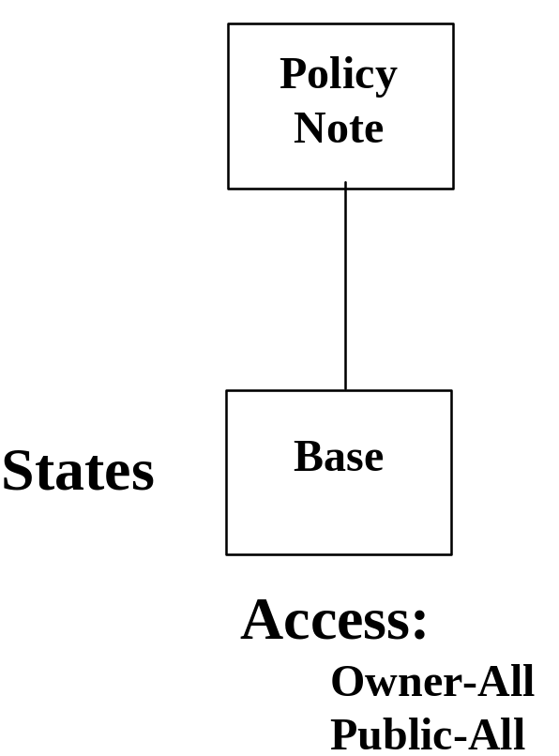

Policy Diagrams - Continued
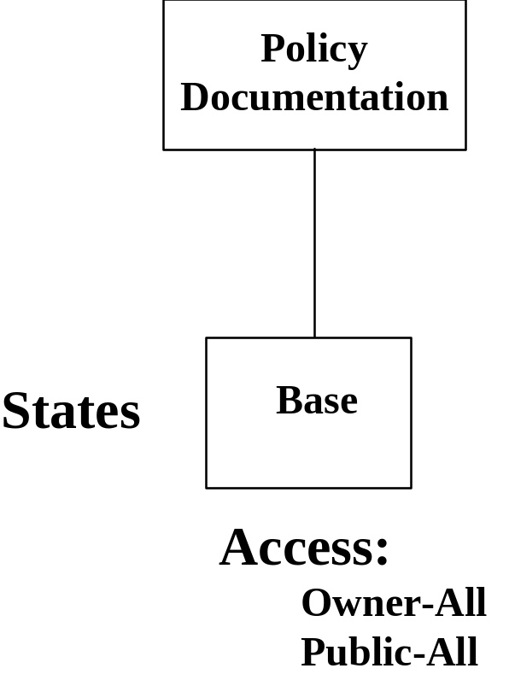

Policy Diagrams - Continued

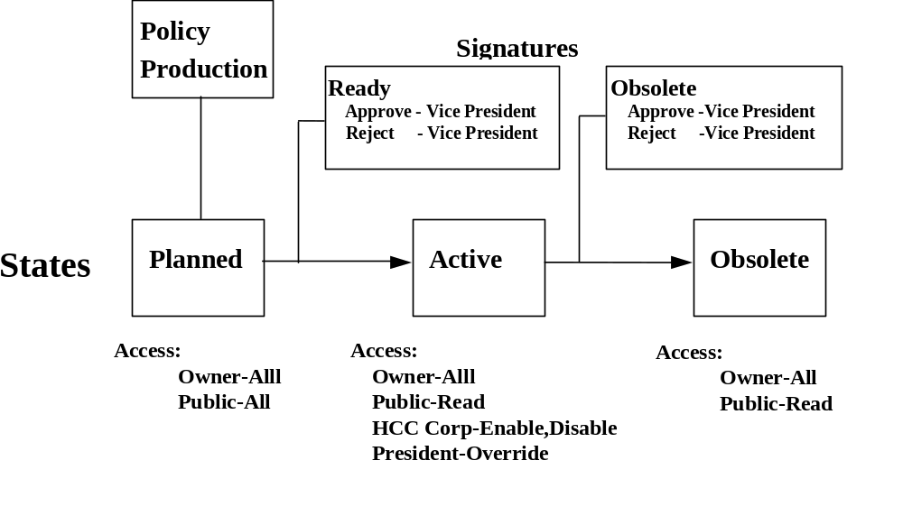

Policy Diagrams - Continued

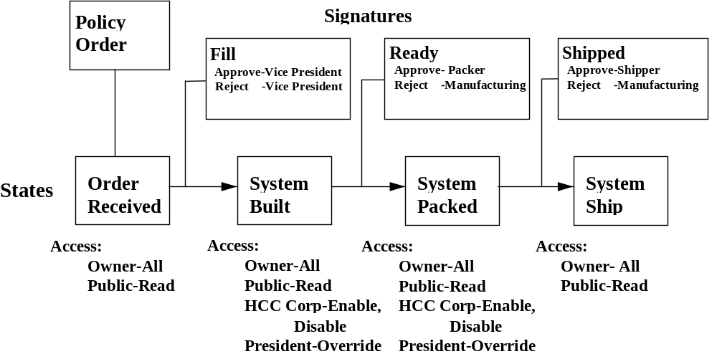

 | Policy, State and Signature Definition Worksheets
Instructions |  | Use this worksheet to specify the policy definitions. State definitions are on the next page. Use the default icons.

General Information | Policy 1
Policy Name
Description
Revision Sequence
Store
Governed Types
Format
Default Format

Policy Name | State 1 | State 2 | State 3 | State 4 | State 5
State Name
Versionable
Revisionable
Owner Access
Public Access
Add User:
User Name & Access

Notify Message
Notify Users
Route Message
Route User
Check
Action

Signature Name
Approval
Reject
Ignore
Branch
Filter

General Information | Policy 2
Policy Name
Description
Revision Sequence
Store
Governed Types
Format
Default Format

Policy Name | State 1 | State 2 | State 3 | State 4 | State 5
State Name
Versionable
Revisionable
Owner Access
Public Access
Add User:
User Name & Access

Notify Message
Notify Users
Route Message
Route User
Check
Action

Signature Name
Approval
Reject
Ignore
Branch
Filter

General Information | Policy 3
Policy Name
Description
Revision Sequence
Store
Governed Types
Format
Default Format

Policy Name | State 1 | State 2 | State 3 | State 4 | State 5
State Name
Versionable
Revisionable
Owner Access
Public Access
Add User:
User Name & Access

Notify Message
Notify Users
Route Message
Route User
Check
Action

Signature Name
Approval
Reject
Ignore
Branch
Filter

General Information | Policy 4
Policy Name
Description
Revision Sequence
Store
Governed Types
Format
Default Format

Policy Name | State 1 | State 2 | State 3 | State 4 | State 5
State Name
Versionable
Revisionable
Owner Access
Public Access
Add User:
User Name & Access

Notify Message
Notify Users
Route Message
Route User
Check
Action

Signature Name
Approval
Reject
Ignore
Branch
Filter

 | Policy, State and Signature Definition Worksheet: Answers
Instructions | Use this worksheet to specify the policy definitions. State definitions are on the next page. Use the default icons.

General Information | Policy 1
Policy Name | Note
Description | Policy to cover the Notes.
Revision Sequence | 1,2,3,…
Store | Production
Governed Types | Note
Format | Word
Default Format | Word

Policy Name | State 1
State Name | Base
Versionable | No
Revisionable | Yes
Owner Access | All
Public Access | All
Add User:
User Name & Access

Notify Message
Notify Users
Route Message
Route User
Check
Action

General Information | Policy 2
Policy Name | Documentation
Description | Policy to govern Specification and Owner Manual
Revision Sequence | 1,2,3,…
Store | Production
Governed Types | Specification, Owner Manual
Format | Word, Excel
Default Format | Word

Policy Name | State 1
State Name | Base
Versionable | No
Revisionable | Yes
Owner Access | All
Public Access | All
Add User:
User Name & Access

Notify Message
Notify Users
Route Message
Route User
Check
Action

General Information | Policy 3
Policy Name | Production
Description | Policy to govern COMPONENTs
Revision Sequence | A,B,C,…
Store | Production
Governed Types | COMPONENT
Format | Word, Excel
Default Format | Word

Policy Name | State 1 | State 2 | State 3
State Name | Planned | Active | Obsolete
Versionable | No | No | No
Revisionable | No | Yes | Yes
Owner Access | All | All | All
Public Access | All | Read | Read
Add User:  User Name & Access |  | HCC - Enable, Disable  President - Override,  Vice-President - Promote, | HCC - Enable, Disable
Notify Message
Notify Users
Route Message
Route User
Check
Action

Signature Name | Ready | Obsolete
Approval | Vice-President | Vice-President
Reject | Vice-President | Vice-President
Ignore
Branch
Filter
Approval
Reject
Ignore
Branch
Filter

General Information | Policy 4
Policy Name | Order
Description | Policy to cover Customer Order.
Revision Sequence | 1,2,3,…
Store | Production
Governed Types | Customer Order
Format | Word, Excel
Default Format | Word

Policy Name | State 1 | State 2 | State 3 | State 4
State Name | Order Received | System Built | System Packed | System Shipped
Versionable | No | No | No | No
Revisionable | No | Yes | Yes | No
Owner Access | All | All | All | All
Public Access | Read | Read | Read | Read
Add User:  User Name & Access |  | HCC - Enable, Disable  President - Override | HCC - Enable, Disable  President – Override | HCC - Enable, Disable
Notify Message
Notify Users
Route Message
Route User
Check
Action

Signature Name | Fill | Ready | Shipped
Approval | Vice-President | Packer | Shipper
Reject | Vice-President | Manufacturing | Manufacturing
Ignore
Branch
Filter
Approval
Reject
Ignore
Branch
Filter

 | Testing and Refining Matrix Schema
Unit Objectives |  | Given the Matrix application and training materials the student will be able to:  - The student will thoroughly test all aspects of this schema through the Matrix interface.  - Test the life cycles, relationships and behavior of the completed system.  - Make notes on the areas that don’t work or could be improved.  - Make connections between business objects as defined by the Business Administrator.
Unit Content |  | Unit content includes:  - Entering test business object data  - Testing the Life Cycles in the schema  - Testing the defined relationships  - Revising the Matrix Schema
Lessons and Topics in this Unit |  | Lessons and topics within each lesson include:  - Creating and Testing Business Objects  - Testing Relationships  - Case Study Exercise: Creating Business Objects  - Making Revisions Test  - Case Study Exercise: Testing Revisions  - Case Study Exercise: Revise the Note  - Case Study Exercise: Revise the Customer Order  - Checking Policies and Life Cycles (States)  - Case Study Exercise: Testing Life Cycles

 | Creating and Testing Business Objects
Introduction |  | You won’t know if your schema works the way you want it to work until you create business objects using Matrix.
How to Create Business Objects |  | The procedure for creating business objects using Matrix includes:

 | Step | Action
 |  | Double click on the Matrix icon in the Matrix Program group in Windows.
 |  | Set context to the person you wish to be.
 |  | From the menus select: Object > New > Original
 |  | An “Original” dialog box appears. There should be an ellipsis box next to the “TYPE” line. Select a type you created in “Business”. The correct Policy and Revision should display.
 |  | In the “Name” field, enter an appropriate name for this Business Object.
 |  | Click on “Create”. The newly created Business Object will display on the Matrix desktop. The “Original” dialog box will disappear and an “Attributes” window will display.
 |  | Select the desired vales from the drop-down-list-boxes and/or enter appropriate values where allowed. Click on “Edit” to save the changes.
 |  | Continue adding new business objects as desired.
 |  | Test the attribute definitions as you add each new business object. Make sure the attributes, values, and defaults are what you wanted them to be.

Object – New, Original
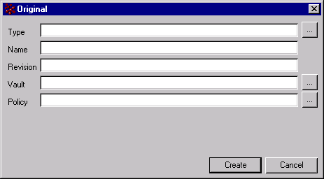

Attributes - System Box “Metro0001” A
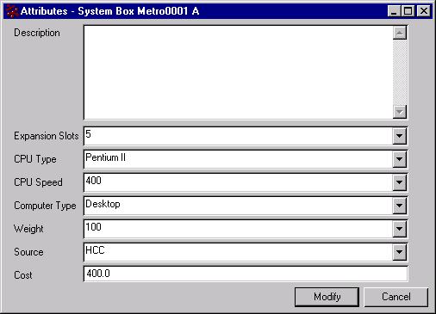

 |  | Creating and Testing Relationships
Introduction | The Matrix user should be able to create a relationship between certain business objects. This relationship is possible because it was originally specified in the “Business” application.
How to Test Relationships | The best way to test a relationship is to create one and see if it behaves the way you want it to behave.
 |  | Step | Action
 |  | 1 | Select an object to be connected “from.”
 |  | 2 | Select the relationship icon, or open the RELATIONSHIPS menu and then select CONNECT.
 |  | 3 | Try to make connections on both the “FROM” and “TO” sides of the relationship. Make sure it behaves the way you want it to behave. If not, make a note of it.
 |  | 4 | Use the “Navigator” or the “Indented Browser” to check your relationship connections. Does it look the way you thought it would look? Are the arrows pointing the way you want them to point?
 |  | 5 | Make a revision to an object. Are the rules governing the relationship working the way you want? If the revision relationship is “None” then nothing happens to the established connection when the object is revised. If the relationship is “Float” then the relationship should shift to the new revision. If the relationship is “Replicate” then the new revision may have more than one simultaneous relationship of the same relationship type.

 | Case Study Exercise: Creating Business Objects
Instructions | Using the Matrix application, create and connect the specified business objects. You may optionally make use of an MQL script to create and connect selected items for this exercise.  - Change context to person Angie, Vault Manufacturing.  - Create the following new business objects:  Type: System Box Name: Metro0001 Revision: A Attributes: CPU Type - Pentium II, CPU Speed - 500, Expansion Slots - 5, Computer Type - Tower, Cost - 400.00, Source - HCC, Weight - 30.  NOTE: The correct Revision, Vault, and Policy should display for each new object created. Also, check to ensure that all the correct Attributes appear, and that the correct selections appear behind each drop-down-list-box. If not, find the problem(s) and correct it(them).  Type: Hard Disk Name: Western Digital 5GB Revision: A Attributes: Capacity in Gigabytes - 5, Cost- 100, Source - Western Digital, Weight – 1.0  Type: Floppy Disk Name: NEC Super Revision: A Attributes: Floppy Type - Super, Cost - 14.00, Source - NEC, Weight - 0.2  Type: RAM Module Name: Micron 128MB Revision: A Attributes: RAM Size - 128MB, Cost - 75.00, Source - Micron, Weight - 0.1  Type: Video Card Name: Diamond 3D 32MB Revision: A Attributes: Video Card Type - 3D, SDRAM Quantity - 32MB, Cost – 70.00, Source - Diamond Multimedia, Weight - 0.3  Type: CD-Rom Name: Toshiba 32X Revision: A Attributes: CD-Rom Speed - 32X, Cost – 45.00, Source - Toshiba, Weight - 0.5  - Using the “System Box Assembly” relationship, connect from the System Box to the Hard Disk (quantity 1), the Floppy Disk (quantity 1), the RAM Module (quantity 2), the Video Card (quantity 1) and the CD-Rom (quantity 1). Check the direction of the connection. What happens if you try to create a connection in the wrong direction? Do the “meanings” help you understand whether to choose “To” or “From”?  - Optional: Start the MQL client and run the script “C:\HCCfiles\HCCspecs.mql”. This will build and connect the Specification objects to the selected business objects according to the diagram on page 3-9. Make sure to refresh your display after completion.

 | Case Study Exercise: Creating Business Object (continued)
Instructions | - Select the System Box “Metro0001”. Using Navigator, navigate your way through the assembled structure. Select one of the arrows and then select “Properties-Basic” from the menu to examine the relationship. Does it look the way you want it to and does it contain the correct information?
TIME | You will have 45 minutes to complete this portion of the case study
System Box Assembly Use the following diagram to help you with this exercise. This diagram is from viewing
Relationship Diagram in Navigator, Star mode, focusing on the System Box business object.

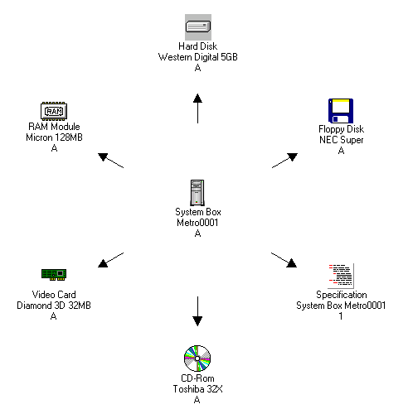

 | Case Study Exercise: Creating Business Objects (continued)
Documentation Relationship Diagram | Refer to the following diagrams to check your results after running the “HCCspecs.mql” script. These diagrams are from viewing in Navigator, Star mode, focusing on the Specification business object.
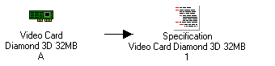
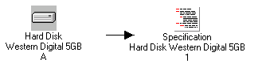

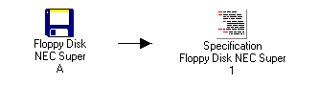

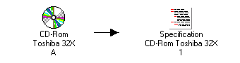
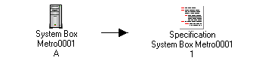
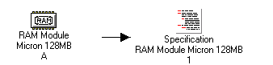

 |  | Case Study Exercise: Creating Business Objects Part II
Instructions: Part II | Use the Matrix application to create and connect the specified business objects.  - Change context to person Darren, Vault Manufacturing..  - Create the following new business objects:  Type: Customer Order Name: Metro0001 Revision: 1 Attributes: Description – “Pentium II/400, 256MB RAM, 32X CD-Rom, 5GB HDD, Super FDD, 17” Monitor, 104 Key Natural Keyboard, 3 Button Mouse, 3D Video Card.”  Type: Monitor Name: ViewSonic 17C Revision: A Attributes: Screen Size in Inches - 17, Dot-Pitch -0.26, Cost - 185.00, Source - ViewSonic, Weight - 25  Type: Mouse Name: MS 3 Button Revision: A Attributes: Mouse Buttons - 3, Cost - 25.00, Source - Microsoft, Weight - 0.2  Type: Keyboard Name: ACME Natural 104 Key Revision: A Attributes: Keyboard Type - Natural, Cost - 15.00, Source – ACME, Weight - 0.75  Type: Microcomputer Name: Metro0001 Revision: A Attributes: Description – Computer for Metro Consulting, Cost - 700.00, Source - HCC, Weight - 30  - Select the Customer Order “Metro0001”. Select the “Object-New-Attachment” function of the Matrix menu to create a Type: Note Name: Metro0001 Revision: 1 Attributes: Description - My first note.  Use the “Order-Note” relationship to connect from the Customer Order to the Note. When Word displays, enter the text “The customer will accept substitutions.” into the note, then close Word, saving the note as “Metro0001”. The file will automatically be checked in to the Note business object.  - Using the Order-Micro relationship, connect from the Customer Order to the Microcomputer (quantity 5). NOTE: You will need to add the attribute “Order-Qty” to the Order-Micro relationship using the Business application.  - Using the Microcomputer Assembly relationship, connect from the Microcomputer to the Monitor (quantity 1), to the System Box (quantity 1), to the Keyboard (quantity 1), and to the Mouse (quantity 1). Check the direction of the connection.  - Optional: Start the MQL client (if not already running) and run the script “C:\HCCfiles\HCCspecs2.mql”. This will build and connect the Specification objects to the selected business objects according to the diagram on page 3-12. Make sure to refresh your display after completion.

 | Case Study Exercise – Creating Business Objects Part II (continued)
TIME | You will have 30 minutes to complete this exercise
Microcomputer Diagram | Refer to the following diagrams to help you with this exercise. The 1st diagram is from viewing in Navigator, Star mode, focusing on the Microcomputer business object. The 2nd diagram is from viewing in Navigator, Star mode, focusing on the Customer Order.

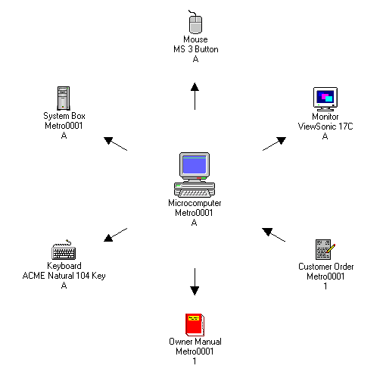

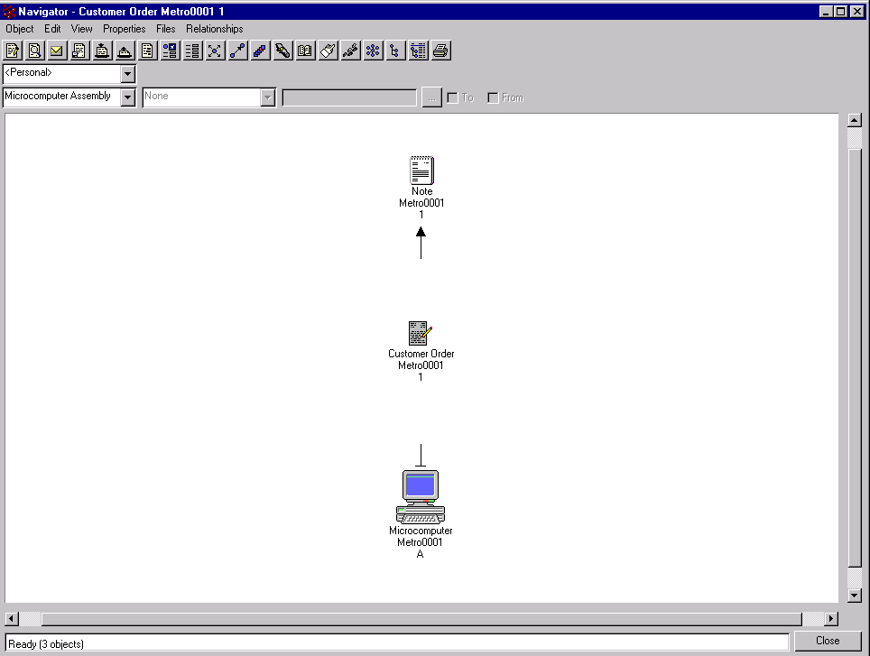
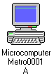
Customer Order Diagram

 | Case Study Exercise – Creating Business Objects Part II (continued)
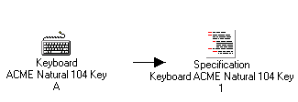  Specification Relationship Diagram | Refer to these diagrams to check your results after running the “HCCspecs2.mql” script. These diagrams are from viewing in Navigator, Star mode, focusing on the Specification business object.

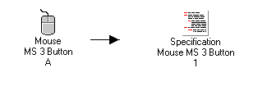
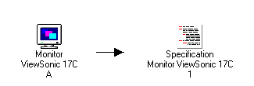
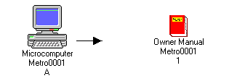

 |  | Creating and Testing Revisions
Overview | The next test of your Matrix schema is to test what happens when you revise a business object.
Testing Guidelines | To test the behavior of the business object after revision you must create a revision of the original business object. After the revision you should ask yourself the following questions:  - Does the business object allow revisions if it’s supposed to?  - Does the revised business object behave the way it is supposed to behave?  - What happens to the relationship after the revision? Does the connection do what you intended it to do?
How to Create/Test Revisions | The best way to test revisioning of a business object is to revise an existing object and see how the revision behaves.
 |  | Step | Action
 |  | 1 | Select an object you wish to revise.
 |  | 2 | From the menus select: Object > New > Revision. The Revision dialog box will display. All of the fields should be filled in, with the Revision value being the next value in the defined Revision Sequence of the Policy for that Business Object.
 |  | 3 | Click Create. This will create a new revision of the selected Business Object, and the Attributes dialog box will display. Select the appropriate values where necessary, then select Edit.
 |  | 4 | Use the “Navigator” or the “Indented Browser” to check your relationship connections. Are the rules governing the relationship working the way you want? If the revision relationship is “None” then nothing happens to the established connection when the object is revised. If the relationship is “Float” then the relationship should shift to the new revision. If the relationship is “Replicate” then the new revision may have more than one simultaneous relationship of the same relationship type.

 |  | Case Study Exercise: Testing Revisions
Revise the System Box | You will revise the System Box “Metro0001” A to revision B. After the revision, the System Box “Metro0001”” A will no longer be connected as part of the structure that you previously built. Notice, however, that both System Boxes are still connected to the object Specification “System Box Metro0001” A. This tests the “From” side Revision Rule of “Float” on the System Box Assembly relationship and the “To” side Revision Rule of “Replicate” on the Documentation relationship.  - Change context to person Darren.  - Revise the System Box Metro000”1 A. It should fail because revisions aren’t allowed in the “Planned” (first) state of the “Production” policy. We want to be able to make revisions in this state. Go back to the “Business” application and open the “Production” policy for editing. Select the “Planned” (first) state for editing, and select the Revisionable check-box. Save your changes. Go back to the “Matrix” application and revise the System Box.  - The newly revised business object will become System Box “Metro0001” B.  - Examine System Box “Metro0001” B in Navigator (Star mode). After the revision, it should look like the following diagram:
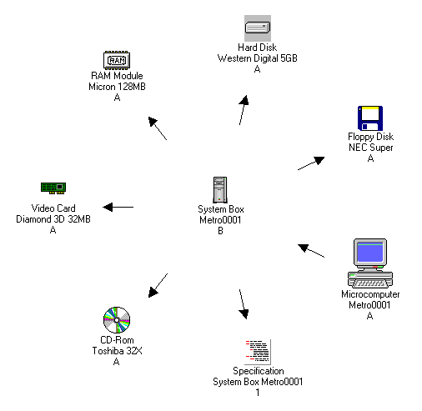

 |  | Case Study Exercise: Revise the Customer Order
Revise the Note | - Change context to person Darren.  - Revise the Customer Order “Metro0001” 1. If the Customer Order will not revise, go into the Business Modeling Application and make any necessary changes.  - Examine the Customer Order “Metro0001” 2 in Navigator (Star mode). After the revision it should look like the diagram below. Notice that the Note is now attached to the Customer Order “Metro0001” 2. The original Customer Order loses the connection. The revised Customer Order gets the new connection because of the “Float” revision behavior on the “From” side in the “Order-Note” relationship
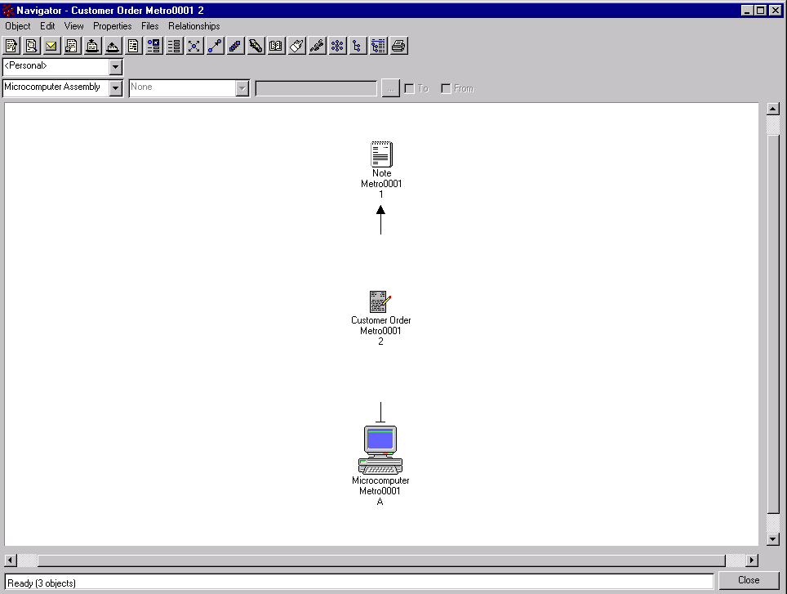

 | Case Study Exercise: Revise the Note
Revise the Customer Order |  | In this example, we will revise the Note “Metro0001” 1 to 2.  - Revise the Note “Metro0001” 1. If the note will not revise, go into the Business application and make the required changes.  - Examine the Customer Order “Metro0001” 2 in Navigator (Star mode). After the revision it should look like the diagram below. The original Note AND the newly revised Note should be attached to the revised Customer Order because of the “Replicate” revision behavior on the “To” side of the “Order-Note” relationship.
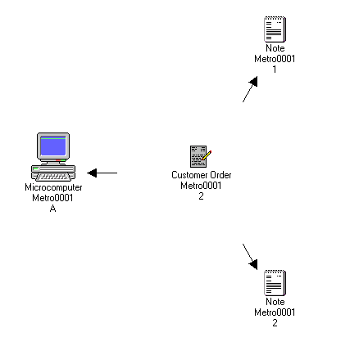

 | Checking Policies and Life Cycles
Introduction |  | Policies may govern many different business objects. You must make sure that the right policy governs the right business object. Each object has a life cycle, a series of states through which it passes during its existence.
Procedure to Check Policy and Life Cycle |  | The procedure to check policy and life cycles follow:

 | Step | Action
 | 1 | Make sure that when you first create a new business object that it provides you with the right policy. There can be only one policy governing the business object.
 | 2 | Select the states icon to bring up the “State Browser” window, or Open the “Properties” menu and select “States”.
 | 3 | Check to see if all the policy states, and state names are in place.
 | 4 | Promote the business object through its entire life cycle. Sign off where you have authority. Change context to different users to see whether or not you can approve or promote business objects. Does it work the way you want it to work? If you can’t sign off on a business object when you should be able to, then something must be fixed -- make a note of it, don’t fix it now.
 | 5 | Test whether or not you can check a file in or out. If not, why not. Take note of all the error messages. Try to check a file in or out of all the file formats.

 | Case Study Exercise: Testing Life Cycles
Instructions |  | Test the life cycle of the business objects by doing the following:
 |  |  | Step | Action
- Move the System Box “Metro0001” B through its life cycle.
- Sign off where you have authority. Remember the sign off person in the first state is the Vice-President (Dave). Change context to Dave and sign off. If you can’t sign off as Dave, then you may not have the proper role assignment for him. Check his assignments in “Business” and make the proper changes. Then sign off on the first state.
- Change context to different users to see whether or not you can approve or promote business objects. Does it work the way you want it to work?
- If you can’t sign off on a business object when you should be able to, or you can sign off when you shouldn’t, then something must be fixed -- make a note of it.

 | 2 | - Move Customer Order “Metro0001” 2 through its life cycle.  - If you can’t promote a business object look at the policy to see who CAN sign off or promote. In the first state, “Order Received” only the owner can promote to the next state. In this case the owner is “Darren”.  - Change context to different users to see whether or not you can approve or promote business objects.  - Try to disable a particular state. Can things be promoted? Only the President has override authority. Change context to Joe and try to promote. What happens?

